December 2017 New Zealand Geothermal Association news
Geothermal Workshop Icebreaker: Awards to Paul Siratovich and Abbie Dean

A very successful annual Geothermal Workshop was held in Rotorua from 21 to 24 November, starting with an NZGA hosted icebreaker function on the Tuesday evening aimed at connecting members of the past, present and futre.
The NZGA presented two Contribution Awards at the event, to the organisers of the event Paul and Abbie, who had arranged the event to involve younger people in the NZGA.

Paul’s award was for surveying members and introducing young member initiatives. The survey carried out earlier this year was very important to the Board enabling it to see what members wanted.

Abbie’s award was for WING initiatives and NZGA branding and member value, work she put in last year leading to the younger member intiatives.
Gordon Dawson receives Contribution Award at 2017 Geothermal Workshop

Gordon Dawson was awarded an NZGA Contribution Award at the Western Energy sponsored social event on Wednesday evening at the Workshop. His award was for, “his work toward the development of geophysical exploration methods, having worked in the field since the 1950s”

Gordon is one of the true pioneers of the New Zealand geothermal industry having started at Wairakei in 1950, where he worked until 1990. It is people like Gordon who developed scientific and engineering methods for exploring and developing geothermal resources that led to Wairakei being known world-wide as a pioneer in the geothermal industry.
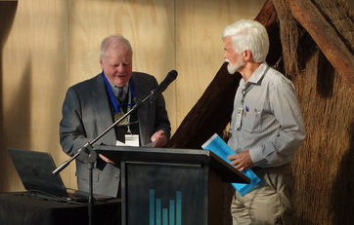
Paul Bixley receives Life Membership honour at 2017 Workshop Dinner

Paul Bixley received honorary Life Membership of the New Zealand Geothermal Association on Thursday evening at the Workshop Dinner. Life membership is limited to ten people.

Paul entered the geothermal community in 1974, when he joined the MWD, Wairakei Projects. In his career he has worked on innumerable geothermal fields in New Zealand, Asia, Africa and Central America, generally as an independent consultant.

Paul has trained very many geothermal scientists and engineers over many years, including in the Geothermal Institute’s training programmes for 20 years following its inception in 1979. He is co-author of the text, “Geothermal Reservoir Engineering”, first published in 1987 with a second edition in 2011.

He has been a member of the NZGA since its formation in 1992 and served on the Board in 1996-97 and from 2009 to 2014.
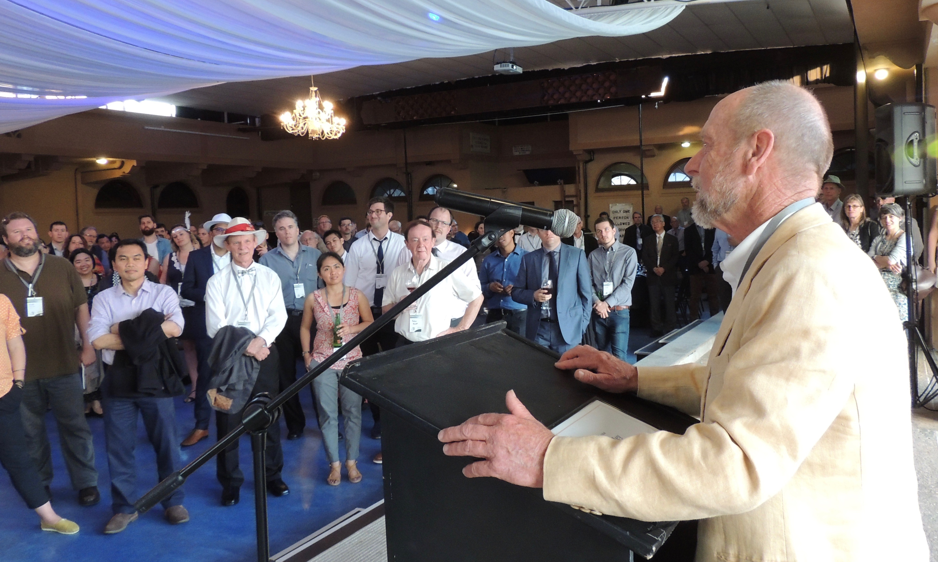

Tim Anderson receives Contribution Award at 2017 Geothermal Workshop

Tim Anderson was awarded an NZGA Contribution Award on Thursday evening at the Workshop Dinner. Tim’s award is for his dedication to the promotion of New Zealand geothermal industry within Indonesia.

Tim has been New Zealand Trade Commissioner to Indonesia since 2013 where he has strongly promted the New Zealand geothermal industry within Indonesia.

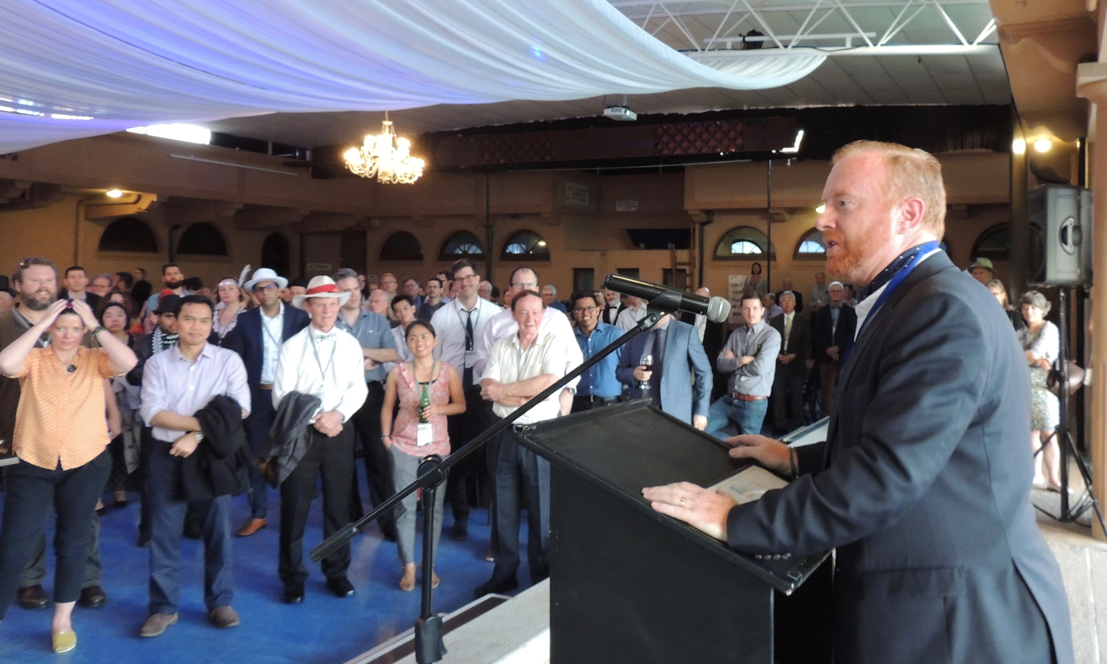
NZGA Awards and Prizes at the NZ Geothermal Workshop Industry Sessions

The NZGA sponsored and organised Industry Sessions on the Friday of the Workshop involved many interesting and insightful talks from a range of industry speaker. The presentations are available on the website: http://nzgeothermal.org.nz/workshop_papers/

At the introductory session on Friday morning Kevin McLoughlin was presented with a Contribution Award. Kevin’s award is for being an outstanding NZGA treasurer. Kevin has retiring from the Board after two years on the Board doing outstanding work as Treasurer and advising the Board through times of change. We are very grateful for his work and wish him well for the future.
Kevin acknowledged the background work that Caitlyn DeSanges has provided in keeping the accounts, promptly, efficiently and smoothly. Kevin received Caitlyn’s Contribution Award in her absence.
The Association introduced two new prizes this year, in addition to the primary Innovative Paper prize. The two new prizes were for the best student paper and the best student poster, receiving $250 and $100, respectively.
The Student Paper prize was awarded to Jericho Omagbon for his paper, “Investigation of Parameter Uncertainty for an Idealized Geothermal Model Using Linear Analysis” (the award was accepted on Jericho’s behalf by John O’Sullivan of The Geothermal Institute).
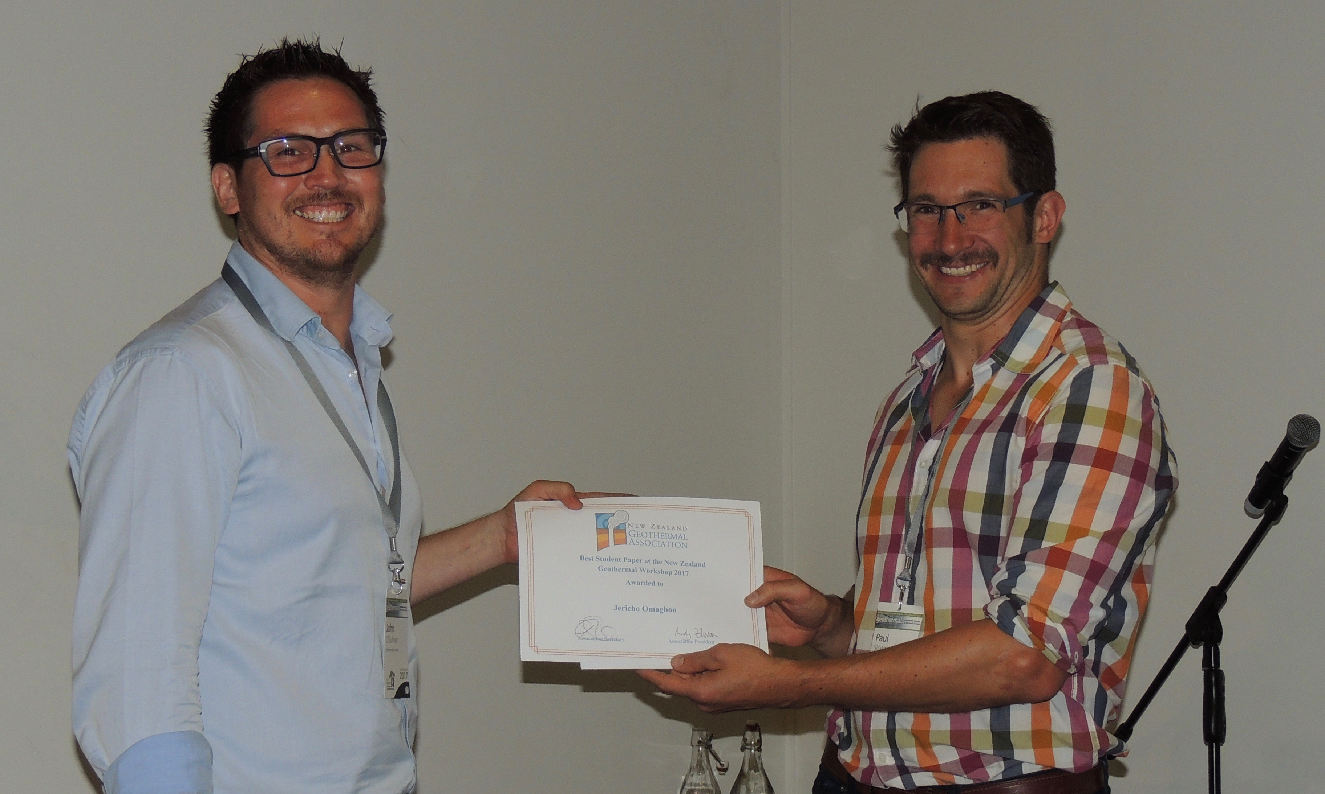
The Student Poster prize was awarded to Morris Young for his poster titled, “Biocide dosing optimisation at Te Mihi power station”.
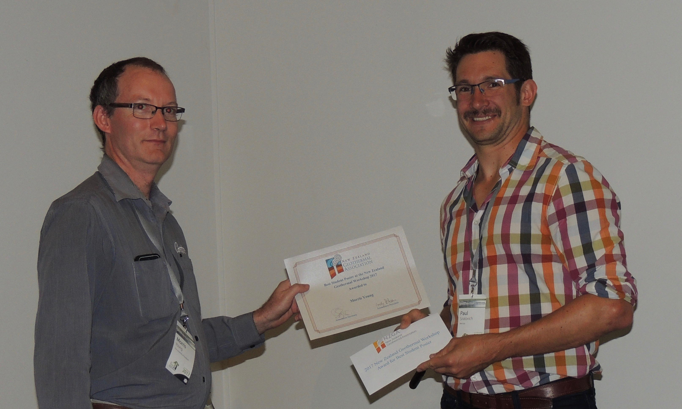
The NZGA prize for Best Paper, Innovation in the Geothermal Industry, was awarded to Sophie Pearson-Grant for her paper, “Numerical Modelling of The Influence of Geology and Groundwater Recharge on Geothermal Systems in The Central TVZ “. As she was absent, the certificate, trophy and $500 prize was accepted on her behalf.
Geothermal Regulations review with Government

A meeting was recently organised by Mercury at their Ngatamariki site with Ministry of Business Innovation and Employment (MBIE) policy advisors presenting them on the impact of geothermal regulations on geothermal operators and the geothermal industry in general. NZGA Board member Boaz Habib attended the meeting representing NZGA. The meeting covered the regulations around geothermal well drilling and health and safety in geothermal operations. A comprehensive overview was provided on drilling rig operation which was followed by a visit to the rig adjacent to Ngatamariki site, run by MB Century.

NZGA is undertaking a geothermal regulations review exercise championed by NZGA Board member Shanon Garden and this meeting was an important milestone is moving this review exercise forward. It is hoped that through this review positive policy changes can be brought about to geothermal regulations that will be of benefit to the geothermal industry as a whole.
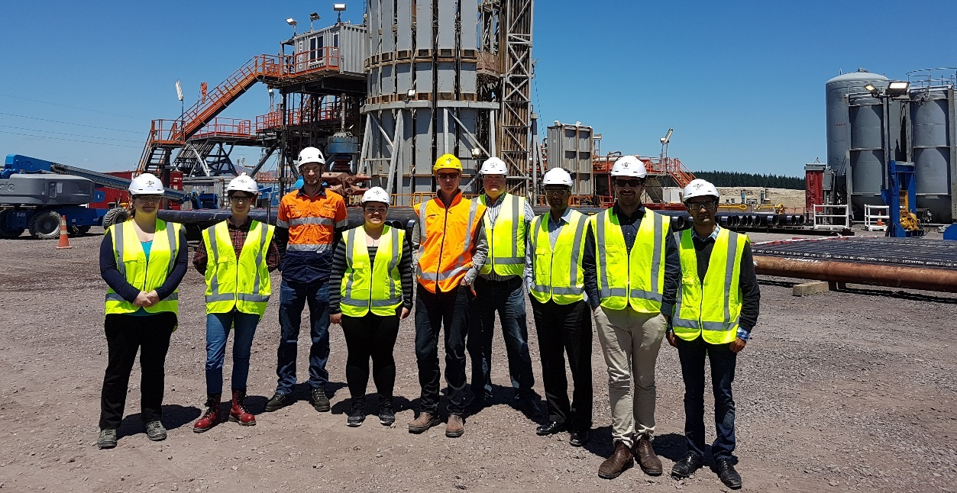
MBIE representatives on their site visit at MB Century Rig 32 following the geothermal regulations meeting held at Mercury Ngatamariki site.
Above Ground Geothermal and Allied Technologies (AGGAT) update

The Above Ground Geothermal and Allied Technologies (AGGAT) research programme administered by the Heavy Engineering Research Association will be closing down this year. A number of collaboration opportunities remain open from this programme in the area of Organic Rankine Cycle technology development in particular a partially commissioned pilot scale Organic Rankine Cycle plant and a geothermal test rig for silica scaling research.
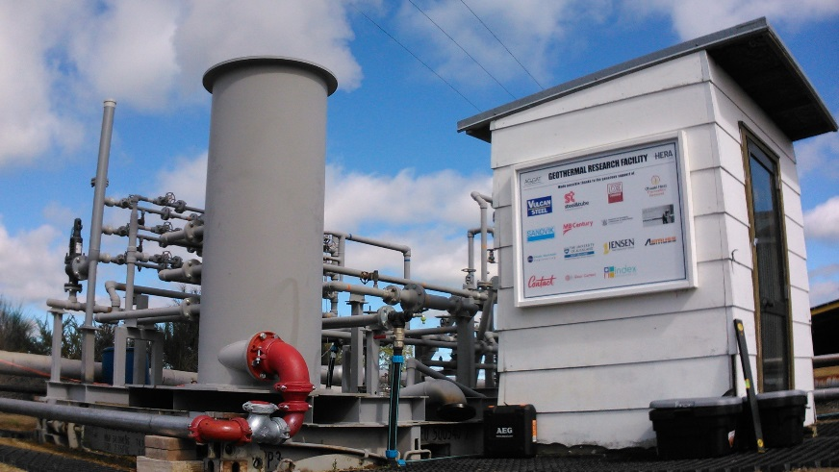
Geothermal test rig for silica scaling research based at Ohaaki geothermal site
Significant research contributions were made through this programme to the geothermal research community. The opportunities remain available for the research community to leverage from in renewable energy technology development and silica scaling investigations.
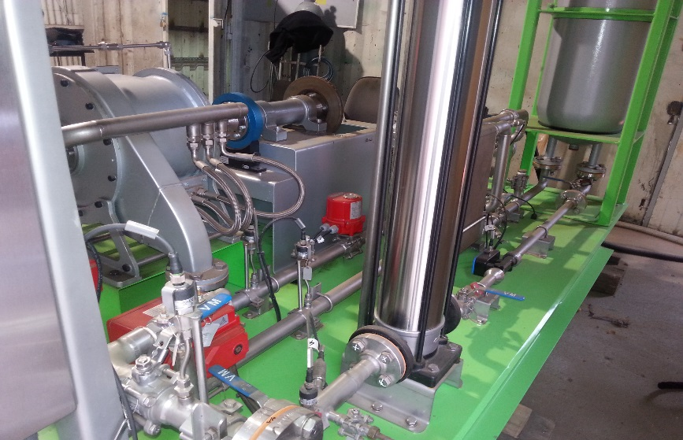
An organic Rankine cycle plant manufactured in NZ by HERA member PFS Engineering for geothermal based power generation (up to 100kW).

Further inquiries about the programme outputs can be made to Manager Industry Development at HERA, Boaz Habib (boaz.habib@hera.org.nz).
Top Energy has signed contracts for Ngawha $176M expansion

Top Energy has signed the major contracts for construction of its new 28MW power station. The civil works required are extensive, “ Over 700,000 cubic meters of dirt will be excavated over three summer periods from October to April, with completion of civil works in 2020”, says Russell Shaw, Top Energy’s Chief Executive. The contract for earthworks has been let to local company United Civil.

Iceland Drilling, with decades of experience in the field of geothermal drilling, including the Ngatamariki geothermal power station near Taupo, will send a specialist team and be based in Northland for one year from April 2018.

Israeli geothermal plant construction experts ORMAT have the contract to design, build and supply the power station which will be commissioned in 2021. Ormat has a long history with the operations at Ngawha supplying the original 10-megawatt power station, which was commissioned in June 1998 and then expanded to 25 megawatts in 2008.

Top Energy had recently received dispensation from the maximum generation rules that apply to electricity distributors. The maximum allowed without exemption is 50MW.
http://topenergy.co.nz/a-head-of-steam-on-geothermal-power-station-expansion/
Leapfrog company ARANZ Geo changes name to Seequent

The company behind geological modelling software Leapfrog has changed its name. On 2 November ARANZ Geo announced today that the company is changing its name to Seequent. The name change and rebrand reflects the company’s expansion into a broader range of global industries and markets.

Seequent leads the world in visualisation of complex scientific data. It first introduced its Leapfrog® 3D geological modelling software to the mining and minerals industry over 10 years ago and has since developed solutions for a wide range of industries including geothermal and renewable energy

Geo40 constructing silica extraction plants at Ohaaki

Geo40 is constructing a plant to extract silica in Contact Energy’s Ohaaki steamfield. The plant is due for commissioning in March next year. After running for three months the second plant will be constructed incorporating any design changes learnt from the first plant.

Geo40, formerly Environmetals, ran trial plants at Wairakei in 2014-2015 and Kawerau last year. http://geo40.com/about
Do you have any news items?

If you have any geothermal news on any topic please forward it to committee@nzgeothermal.org.nz for inclusion in the next newsletter.

